**Calculation of existence domains and optimized phase diagram for the Nb-Ti binary alloy system using computational methods**

**ABHISHEK KUMAR THAKUR, VIVEK KUMAR PANDEY, VIKAS JINDAL,   
B NAGESWARA SARMA AND S LELE**

Department of Metallurgical Engineering, Indian Institute of Technology, Banaras Hindu University, Varanasi 221005, India

**ABSTRACT**

**We present the thermodynamic modeling for the Nb-Ti binary alloy system using CALPHAD (CALculation of PHAse diagram) and CE-CVM (Cluster expansion – Cluster variation method) focusing on the solid solution part of the system. Existence domains for invariant reactions between the interaction parameters of the system were calculated between BCC and HCP phases. Five different regions viz. Simple Isomorphous, Monotectoid, Simple Isomorphous with congruent maxima, Monotectoid with congruent maxima and Syntectoid were identified in the calculated existence domains each of which has a characteristic reactional topology. The calculated existence domains are in good agreement with the earlier thermodynamic assessments on the Nb-Ti system. Further we have used first principles calculation (using Quantum espresso) to generate thermochemical data for BCC and HCP phases in Nb-Ti system. Moreover, we have calculated the optimized phase diagram using the calculated existence domains, earlier experimental data and generated thermochemical data for the Nb-Ti system.**

**Keywords. CALPHAD; CE-CVM; Invariant reactions; Phase diagram; Thermochemical data.**

**INTRODUCTION**

Phase diagrams are extremely important in materials design and development. A clear understanding of alloy phase stability under various service conditions is of fundamental and paramount importance in the efficient design and economic development of materials as well as in their heat treatment cycles and processing routes. These diagrams graphically represents the phase fields, or the region of thermodynamic stability of various phases present in materials system under equilibrium conditions as functions of thermodynamic state variables such as composition and temperature or composition and pressure. The experimental determination of phase diagrams of multicomponent system is laborious and expensive, since the number of experiments needed to be carried out increases enormously with the number of components in the alloy system. Resorting to theoretical calculations can effectively minimize the effort required for determining the phase diagrams of such systems. The knowledge of phase stability and thermodynamics of constituent subsystems can be extrapolated to determine a preliminary phase diagram of the multicomponent system of interest. This predicted phase diagram can further be used to identify the crucial regimes of composition and temperature where maximum information can be obtained with minimal experimental effort.

Recently titanium and its alloys have attracted a large number of researchers because of its excellent biocompatible properties [1]. Apart from biomedical applications, titanium alloys finds a large number of applications in various other fields which requires high strength and low young’s modulus such as load bearing applications [2]. These make the study of titanium and its alloys extremely important. Pure titanium is HCP (α) at lower temperature and after 1155K it transforms to BCC (β) phase. Niobium, on the other hand, is BCC at low temperatures and transforms to liquid at 2750K. The diffusion of Niobium in Titanium is very sluggish and thus it takes a lot of time to for the system to attain thermodynamic equilibrium. There is an almost flat topology in Nb-Ti phase diagram along β/α+β boundary leading to the suspicion of having an invariant reaction. This interesting fact in the Nb-Ti binary alloy system has attracted many materials researcher and that is why there is a need to study various possible reactional topologies in Nb-Ti system. One way to do this is to make existence domains between BCC and HCP solid phases. Sarma et. al., have studied various reactional topologies earlier in 2003 by making an existence domains between solid and liquid phases [5]. Since there is no existence domains made between any two solid phases earlier, we have focused this work in exploring the various invariant reactions and the set of interaction parameters which leads to different invariant reactions in an Nb-Ti binary alloy system.

**THERMODYNAMIC MODELS**

**PURE ELEMENTS**

The temperature dependence of the Gibbs energy of a pure component *A*, is described by a power series in temperature [30]:

 (1)

where  etc are constants and represents the enthalpy of the component *A* in its reference state, usually the stable state at 298.15K and 1 bar. This representation has been accepted internationally as standard. Such power series is valid only for a limited range of temperature usually well above the Debye temperature and here delimited by  and . The data for each phase are stored in the form of Gibbs energies relative to the  in the internationally accepted SGTE database. Additional terms are added to the above expression to account for pressure dependence or magnetic contributions, if required.

**SOLUTION PHASES**

**REGULAR SOLUTION MODEL**

Consider two solid phases are present in the system. Let us say  be the lower temperature solid phase while  be the higher temperature solid phase. The molar free energy of  and  phase can be expressed as:

(2)

(3)

where  and  are the mole fraction of component B in  and  phase,  and are standard molar free energies of components A and B in  phase,  and  are standard molar free energies of components A and B in  phase respectively.  and  are the interchange energy parameters of  and  phase respectively.  is the temperature while  is the gas constant.

The chemical potentials of components A and B in  and  phase are given by:

 (4)

 (5)

 (6)

 (7)

The free energies for the transformation from  to  phase can be expressed in terms of enthalpies  and entropies  of transformation of pure components as:

 (8)

 (9)

where  and  are the transformation temperatures of pure A and pure B respectively.

We recall the equilibrium condition between two phases given by Van Laar[3], the chemical potential of each component in both the phases should be same. This can be expressed mathematically as:

 and  (10)

after simplification of (10) we obtain:

 (11)

 (12)

The iso-G curve between two phases  and  can be expressed as:

 (13)

where . On substituting (2) and (3) in (13) and using (8) and (9), we get:

 (14)

where . The value of and  are taken from standard SGTE database. The miscibility gap boundary in  and  phases are given by:

 (15)

 (16)

The maximum temperature in a miscibility gap boundary in  and  phases, i.e. the consolute point are given by:

 (17)

 (18)

**CLUSTER EXPANSION – CLUSTER VARIATION MODEL (CE-CVM)**

The earliest model given which treats the presence of short range ordering in the materials system is proposed by Ernst Ising in 1925[4]. Later it was realized that Ising’s model has no analytical solution in the more physically relevant three dimensions. In 1934, Bragg &Williams[5-7] proposed a model for treating order disorder transformation and by Gorsky[8] independently in 1928. They used first neighbor pair interaction to model enthalpy but random behavior is assumed while modeling entropy of the system. So this model doesn’t account for the ever present short range ordering. In 1935 Bethe considered first nearest neighbor pair approximation but the cluster size is very small[9]. Guggenheim proposed Quasi-chemical theory in 1935[10,11]. In this, enthalpy is modeled by pair-wise interaction while entropy is modeled with larger clusters. Kikuchi proposed cluster variation method in 1951 which gives a flexible and powerful method to treat local ordering[12-17]. Larger clusters in the model give more accurate results as compared to smaller clusters while increasing computational burden at the same time.

In CVM, the configurational entropy is expressed as summation of Boltzmann entropy terms corresponding to the cluster and subcluster configurations such that each of these configurations is counted only ones.

 (19)

Where,  Boltzmann’s constant

 = Thermodynamic probability for the formation of distinct configuration for a  
 given value of correlation functions.

Cluster expansion method is developed by Sanchez and De Fontaine in 1978 [18,19]. They introduced multisite correlation functions, which form a natural set of independent variables for expressing internal energy of a system. Enthalpy can be expressed as bilinear sum in a set of complete orthonormal cluster functions and their respective coefficients.

 (20)

Where,  = Correlation functions.  
  = multiplicity corresponding to the respective correlation function ‘’.   
  = cluster expansion coefficients.

For Nb-Ti system we have to model BCC and HCP phases according to CVM formulation. The formulation is done by Sarma *et. al* [20] for both BCC as well as for HCP phase. We have used that model for modeling solid phases in Nb-Ti system. Corresponding thermodynamic equations were made and were solved numerically to obtain desired properties of the system.

**METHODOLOGY**

**EXISTENCE DOMAINS**

Before the assessment of Ti-Nb binary alloy system, we made an existence domain of energy interchange parameters (Wα and Wβ). This will assist in taking the initial values of Wα and Wβ in the final assessment of the system. To make existence domains, we first identify different probable reactions which are likely to happen for various combinations of Wα and Wβ. Since there is no congruent minimum in the system and Nb doesn’t transform from BCC to any other structure till its melting point, the formation of eutectoid, peritectoid, peritectoid with congruent minimum and congruent minimum with miscibility gap in higher temperature phase are ruled out. We have further explored the possibilities of different types of phase diagrams and ended up with simple isomorphous, simple isomorphous with congruent maximum, monotectoid, monotectoid with congruent maximum and syntectoid. Two existence domains were made depicting the boundary between different types of reaction, one each using regular solution model and CE-CVM. The methodology of the occurrence of each type of phase diagram is discussed in further steps.

**BOUNDARY BETWEEN SIMPLE ISOMORPHOUS AND CONGRUENT MAXIMUM**

The transformation temperature of Ti from HCP to BCC is 1154.99K. Recalling the fact that occurrence of congruent maximum will always be in the second half of the composition axis[21], i.e. and the congruent maximum temperature will always be greater than the transformation temperature of Ti. The onset of congruent maximum can be characterized by a negative slope in  vs  curve at . Alternatively, the condition for the occurrence of congruent extremum can be found by differentiating (16) w.r.t  and equating it to 0.

 (21)

where .

We have calculated the value of from (21) and subsequently different combination of and  can be calculated.

Using CE-CVM, to obtain the boundary between simple isomorphous and congruent maximum, we fix  to a particular value, *α* phase composition to 0.9, *β* phase composition to 0.99 and then value was systematically changed until we get 1154.99K as the equilibrium temperature between the two phases. Let’s call this value . Again we repeat the same process by changing *β* phase composition to 0.98 (i.e. ). We obtain the difference as follows:

 (22)

We obtained the value of  by extrapolating it to *β* phase composition of 1.0 by adding the difference obtained in (19) to  as follows:

 (23)

This process is done for a series of  value the obtained data set was plotted to get the required boundary.

**BOUNDARY BETWEEN SIMPLE ISOMORPHOUS AND MONOTECTOID**

A monotectoid reaction can occur in a phase diagram when there is: (i) a miscibility gap in the higher temperature solid phase and (ii) the maximum of miscibility gap in the higher temperature solid phase intersects the  boundary. A syntectoid reaction will occur instead of a monotectoid reaction if the system exhibits congruent maximum rather than simple isomorphous. The limiting case for the occurrence of monotectoid reaction is when the maximum in miscibility gap boundarytouches the boundary.

 (24)

We fix the  value and vary  accordingly till the above condition is met. This procedure is repeated for a series of values of.

Similar procedure was adopted to calculate the boundary between simple isomorphous and monotectoid numerically. First we fix  to a desired value and calculate the spinodal temperature corresponding to that  value (say). Then we calculate the equilibrium temperature (say *T*) between the two phases by fixing *β* phase composition to 0.5 and systematically varying the  value such that. The corresponding set of  and  are noted and the process is repeated for a series of  values. These set of interchange energy parameters will give the desired boundary.

**BOUNDARY BETWEEN MONOTECTOID AND SYNTECTOID**

A syntectoid reaction will occur in a phase diagram when there is: (i) a congruent maximum in the system, (ii) a miscibility gap in the high temperature phase and (iii) the congruent maximum point lies inside the miscibility gap boundary.The formation of monotectoid with a congruent maximum will takes place instead of a syntectoid reaction when the miscibility gap boundary intersects the  boundary but the point corresponding to congruent maximum lies outside the boundary. Thus the limiting case for a syntectoid reaction corresponds to when the point corresponding to congruent maximum lies at the boundary of miscibility gap. The miscibility gap in  phase can be found by using (18) while (21) gives the condition of congruent extremum. Again we fix the  value and vary  accordingly till the above conditions are achieved. The procedure was then repeated for a series of values of.

To obtain the boundary between monotectoid and syntectoid numerically, we first fix the  value and obtained its corresponding  value from congruent maximum boundary. We calculate the congruent point ( and) and miscibility gap composition () at this set of interchange energy parameters. Then we systematically change  value and calculate congruent point and miscibility gap composition. The condition for syntectoid formation is met when  *>*. The set of interchange energy parameters should be noted and the process is repeated for different values of.

**FIRST PRINCIPLES CALCULATIONS**

We have used quantum espresso for first principles calculations. It is carried out in order to calculate the thermochemical data of an alloy system. Total energy of the system is calculated by solving Kohn-Sham equations with PBE exchange correlation effect and plane wave energy cutoff of 55 Ry, K-points mesh of 3000 and mixing beta 0.6. For cluster expansion, we have used ATAT software package.

**THERMODYNAMIC ASSESSMENT**

Earlier assessments were done for Nb-Ti system, thus we have done a reassessment for this system .The reassessment has been done by collecting all the available experimental data for Ti-Nb system[22-28] and fitting it into a model having adjustable parameters in a way that generated parameters can efficiently be used to reproduce the existing experimental data and the corresponding phase diagram.

Suppose that there are *N*experimental data points ,  and the model has *M*adjustable parameters , , which is represented by vector . The there will be a functional relationship set up using the adjustable parameters as:

 (25)

Depending upon the choice of, there exist a deviation (error) between the observed and calculated values corresponding to each data point which is given by:

 (26)

We also calculate the standard deviation () corresponding to each data point and thus define a merit function which is the sum of squares of ratios of errors to the respective standard deviations:

 (27)

Here,  is a function of. Thus  is minimized with respect to  in order to obtain a set of parameters which characterises the system. For this purpose we have used the Levenberg-Marquardt algorithm since it has become a problem of non-linear least square minimization.

**RESULTS AND DISCUSSIONS**

EXISTENCE DOMAINS

The calculated existence domain using regular solution model for Ti-Nb system is shown as follows:

Figure 1: Existence Domains for different topologies in Ti-Nb binary alloy system using Regular solution model.

Table 1: Different regions of the existence domain and their system characteristics

|  |  |
| --- | --- |
| REGION | SYSTEM CHARACTERISTIC |
| A | Simple Isomorphous (SI) |
| B | Monotectoid (MO) |
| C | MO + Congruent Maxima (MX) |
| D | Syntectoid (SY) |
| E | SI + MX |

The calculated existence domain using CE-CVM for Ti-Nb system is shown as follows:

Figure 2: Existence Domains for different topologies in Ti-Nb system using Cluster Expansion-Cluster Variation Method.

On comparing the two obtained existence domains, we found that the boundary between monotectoid and syntectoid as well as boundary between monotectoid and simple isomorphous with congruent maxima obtained through CE-CVM shifts towards right and upwards when compared to that obtained from regular solution modeling (see Figure 3). It should be noted that the position of the boundary between simple isomorphous and simple isomorphous with congruent maxima also shifts towards right in the case of CE-CVM, but the shift is very nominal. This shift in the boundaries can rightfully be attributed to the effect of short range ordering in materials as considered in the case of modelling through CE-CVM. The assessed parameters of Y. Zhane*et. al.* and the data taken from COST-501 database has been superimposed over the calculated domain as shown in Figure 4. These data are in agreement of the reaction topology predicted by the calculated domain.

Figure 3: Comparison between existence domains for different topologies in Nb-Ti system obtained using regular solution model and Cluster Expansion-Cluster Variation Method.

Figure 4: Earlier assessed parameters and parameters assessed in this work for Nb-Ti system.

Optimized phase diagram

The optimized parameters using various experimental data for Nb-Ti binary alloy system has been shown below in Table 2. We have considered I-n pair approximation in modelling HCP phase while I-n pair as well as tetrahedron approximation while modelling HCP phase. We have calculated the optimized set of Effective Cluster Interactions (ECI’s) for liquid, BCC and HCP phases.

Table 2: ECI parameters used in optimization of Nb-Ti phase diagram using experimental data.

|  |  |  |  |
| --- | --- | --- | --- |
| CLUSTER | SYMBOL | Nb-Ti System | |
|  |  | Configurational ECI | Vibrational ECI |
| ***α* - phase** | | | |
| I-neighbor pair | $$C_{2}^{α}, B_{2}^{α}$$ | -1657 | - |
| II-neighbor pair | $$C_{3}^{α}, B_{3}^{α}$$ | - | - |
| NNN pair | $$C_{4}^{α}, B_{4}^{α}$$ | - | - |
| Octahedral basal triangle | $$C_{5}^{α}, B_{5}^{α}$$ | - | - |
| Tetrahedral basal triangle | $$C_{6}^{α}, B_{6}^{α}$$ | - | - |
| Triangle inside octahedron | $$C_{7}^{α}, B_{7}^{α}$$ | - | - |
| Out-of-plane triangle | $$C_{8}^{α}, B_{8}^{α}$$ | - | - |
| Tetrahedron | $$C_{9}^{α}, B_{9}^{α}$$ | - | - |
| Rectangle inside octahedron | $$C_{10}^{α}, B_{10}^{α}$$ | - | - |
| Irregular tetrahedron inside octahedron (4-pt2) |  | - | - |
| Irregular tetrahedron inside octahedron (4-pt3) |  | - | - |
| Rectangular pyramid | $$C_{13}^{α}, B_{13}^{α}$$ | - | - |
| Octahedron | $$C_{14}^{α}, B_{14}^{α}$$ | - | - |
| ***β* - phase** | | | |
| I-neighbor pair | $$C_{2}^{β}, B_{2}^{β}$$ | -765 | - |
| II-neighbor pair | $$C_{3}^{β}, B_{3}^{β}$$ | - | - |
| Triangle | $$C_{4}^{β}, B_{4}^{β}$$ | - | - |
| Irregular tetrahedron | $$C_{5}^{β}, B_{5}^{β}$$ | - | - |
| **Liquid** | | | |
|  | *L* | 16132 | - |

OPTIMIZED PHASE DIAGRAM WITH EXPERIMENTAL DATA

The optimized phase diagram for Nb-Ti system using experimental data is shown as follows:

Figure 5: The optimized phase diagram of Nb-Ti system.

Figure 6: The solidus boundary of the optimized phase diagram of Nb-Ti system.

Figure 7: The optimized α/α+β and β/α+β boundary of Nb-Ti system.

THERMOCHEMICAL DATA

However, the addition of thermochemical data severely changes the topology of the phase diagram. The cluster expansion of the system in BCC and FCC phase using first principles calculation is shown below:

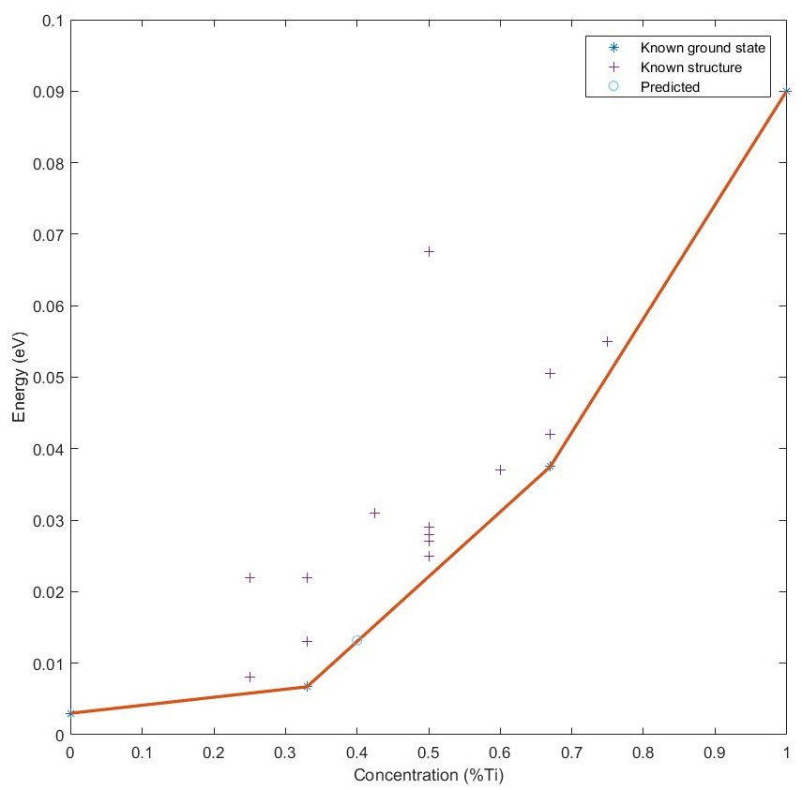

Figure 8: Convex hull of Nb-Ti system in BCC phase. The hull represents Nb is more stable than Ti in the BCC phase.

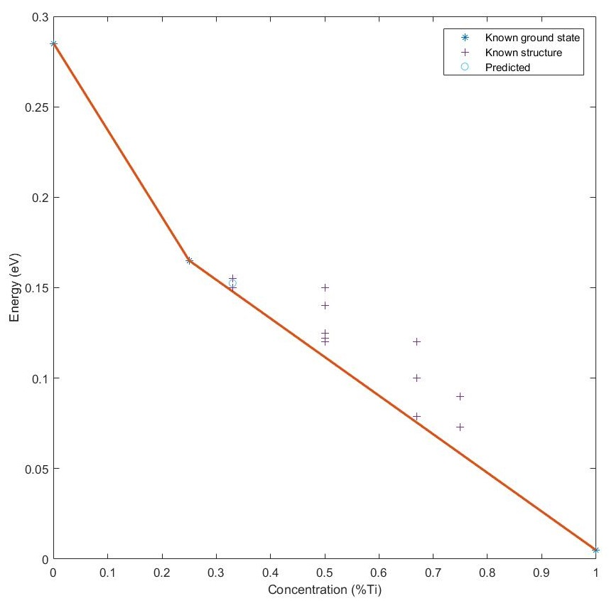

Figure 9: Convex hull of Nb-Ti system in HCP phase. The hull represents Ti is more stable than Nb in the HCP phase.

Figure 10: Calculated formation enthalpy for different alloy composition for Nb-Ti system.

Table 3: Calculated formation enthalpy and mixing enthalpy of different alloy composition of BCC phase for Nb-Ti system.

|  |  |  |  |
| --- | --- | --- | --- |
| *%Ti* | $$H_{f}^{bcc} (eV)$$ | $$H_{mix}^{bcc} (eV)$$ | $$H_{mix}^{bcc} (kJ/mol)$$ |
| 0.0 | 0.295090 | 0 | 0 |
| 0.25 | 0.161121 | -0.018686 | -1.802924 |
| 0.33 | 0.143014 | -0.024915 | -2.403931 |
| 0.50 | 0.107586 | -0.024916 | -2.404028 |
| 0.67 | 0.072155 | -0.024916 | -2.404028 |
| 0.75 | 0.054569 | -0.018687 | -1.803021 |
| 1.0 | 0.001550 | 0 | 0 |

Table 4: Calculated formation enthalpy and mixing enthalpy of different alloy composition of HCP phase for Nb-Ti system.

|  |  |  |  |
| --- | --- | --- | --- |
| *%Ti* | $$H_{f}^{hcp} (eV)$$ | $$H_{mix}^{hcp} (eV)$$ | $$H_{mix}^{hcp} (kJ/mol)$$ |
| 0.0 | 0.00342600 | 0 | 0 |
| 0.25 | 0.00634518 | -0.061065 | -5.891875 |
| 0.33 | 0.00736041 | -0.054280 | -5.237222 |
| 0.50 | 0.02182740 | -0.040710 | -3.927917 |
| 0.67 | 0.03642130 | -0.027140 | -2.618611 |
| 0.75 | 0.04974620 | -0.020355 | -1.963958 |
| 1.0 | 0.09355300 | 0 | 0 |

Table 5: ECI parameters used in optimization of Nb-Ti phase diagram using experimental as well as thermochemical data data.

|  |  |  |
| --- | --- | --- |
| Cluster | Nb-Ti system | |
| Configurational ECI (J/mol) | Vibrational ECI (J/mol) |
| ***β* – Phase** | | |
| I-neighbour pair | 310 | - |
| II-neighbour pair  (2/3rd of I-n pair) | 206 | - |
| Triangle | - | - |
| ***α* – Phase** | | |
| I-neighbour pair | 682 | - |
| II-neighbour pair | - | - |
| Triangle | -52 | - |
| ***Liquid*** | | |
|  | -13290 | - |

Figure 11: Optimized phase diagram of Nb-Ti system using experimental as well as thermochemical data. We have used I-n, II-n pairs and triangle interactions.

Figure 12: The interaction parameters of the optimized phase diagram shown in figure 11 falls inside simple isomorphous area which further verifies the existence domains.

THERMODYNAMIC PROPERTIES

With the optimized ECI values we have calculated the integral properties of liquid and solid phases at 2800K and 1500K respectively. Moreover we have calculated the partial quantities of Nb and Ti in liquid and solid phases at the respected temperatures.

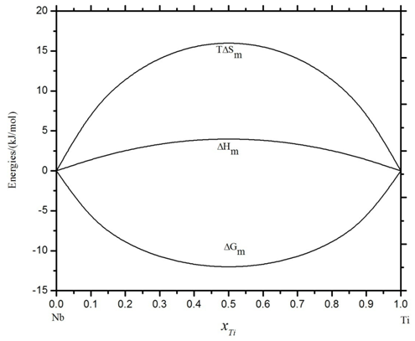

Figure 13: Integral properties of liquid phase at 2800K.

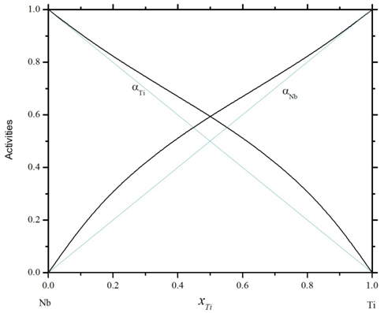

Figure 14: Activities of Nb and Ti in the liquid phase at 2800K.

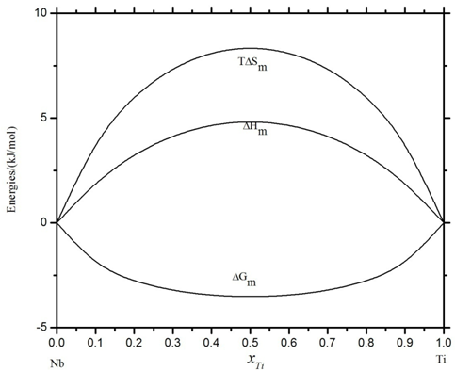

Figure 15: Integral properties of solid phase at 1500K.

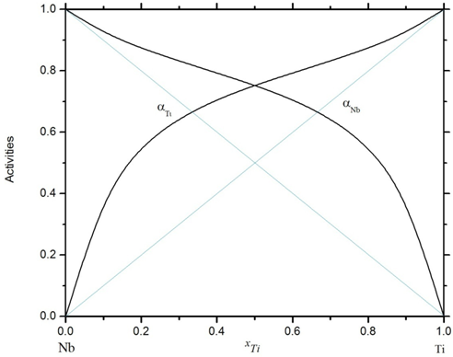

Figure 16: Activities of Nb and Ti in the liquid phase at 1500K.

**CONCLUSION**

We have explored the possibilities of different types of phase diagram topologies which can occur in an Nb-Ti binary alloy system. This has been studied using two different models viz. regular solution model and CE-CVM. We have ruled out the possibility of formation of simple isomorphous system with congruent minimum because of the fact that niobium doesn’t show any solid state transformation above 0K. Thus the possible phase diagrams which consists the feature of congruent minimum has been ruled out. Finally we ended with with five different regions viz. simple isomorphous, simple isomorphous with congruent maximum, monotectoid, syntectoid and monotectoid with congruent maximum. We have drawn existence domains depicting these regions as a function of interchange energy parameters of BCC and HCP phases using regular solution as well as using CE-CVM. On comparing these two domains, we found that the domains made by CE-CVM shifts towards right and upwards to that obtained by using regular solution model. We attributed this shift as a result of short range ordering, which is absent in regular solution modelling while it is taken into account in modeling using CE-CVM.

We carried out the optimization of Nb-Ti phase diagram using earlier experimental data of Nb-Ti binary alloy system and using both experimental data as well as thermochemical data. To generate thermochemical data, we have used first principles calculation using Quantum espresso. For optimization, we have defined an appropriate Merit function which is minimized with respect to the adjustable parameters. Levenberg-Marquardt algorithm has been used for this purpose. The optimized values of effective cluster interaction (ECI’s) have been used to calculate the phase diagram and other thermodynamic properties of the system.

**REFERENCES**

[1] Niinomi M, Nakai M, Heida J, Development of new metallic alloys for biomedical applications, Actabiomater, 8(2012), 3888-3903.

[2] Tane M, Akita S, Nakano T, Hagihara K, Umakoshi Y, Niinomi M, H Nakajima, Peculiar elastic behavior of Ti-Nb-Ta-Zr single crystals, Acta mater. 56(2008), 2856-2863.

[3] J.J Van Laar, Z. Phys. Chem. 63 216; 64 257, 1908.

[4] Ising E, 1925, Z. Phys, 31, 253.

[5] Bragg W.L, and Williams E.J, 1934, Proc, Roy, Soc, 145A, 699.

[6] Bragg W.L, and Williams E.J, 1934, Proc, Roy, Soc, 151A, 540.

[7] Bragg W.L, and Williams E.J, 1934, Proc, Roy, Soc, 152A, 231.

[8]Gorsky V.S, 1928, Z. Phys, 50, 64.

[9] Bethe H.A, 1935, Proc, Roy, Soc, 150A, 552.

[10] Guggenheim E.A, 1935, Proc, Roy, Soc, 148A, 304.

[11] Guggenheim E.A, 1952, mixtures (Oxford univ. press).

[12] Kikuchi R, 1951, Phys, Rev, 81, 988.

[13] Kikuchi R, 1977, J. De Physique, Coll, C7, Suppl, 38, 307.

[14] Kikuchi R, 1987, Physica, 142A, 321.

[15] Kikuchi R, and De Fontaine D, 1978, Application of phase diagrams in metallurgy and ceramics (NBS), p. 967-988.

[16] Kikuchi R, and Sato H, 1974, Actametall, 22, 1099.

[17] Kikuchi R, and Van Baal C.M, 1974, Scr, Metall, 8, 425.

[18] De Fontaine D, 1979, Solid State Physics, 34, 73.

[19] Sanchez J.M, and De Fontaine D, 1978, Phys, Rev, B17, 2926.

[20] Sarma B.N, Shah S.N, Kumar M, Lele S, 2012, International Journal of Materials Research, vol. 103, no. 10, pp. 1188-1200, 2012.

[21] H.A.J Oonk, Phase Theory: The thermodynamics of heterogeneous equilibria (Amsterdam: Elsevier), pp. 125, 1981.

[22] B.N Sarma, S.S Prasad, S Vijayvergiya, V.B Kumar and S. Lele, Bull. Mater. Sci., Vol. 26, No. 4, pp. 423 – 430, 2003.

[23] Rudy E., 1969, Technical report, AFML-TR-65-2, part 5, Wright Patterson air force base, “Compilation of phase diagram data”.

[24] Hansen M, Kamen E.L, Kessel H.D, and McPherson D.J, 1951, Trans AIME, 191, 881-888.

[25] Imgram A.G, Williams D.N, Wood R.A, Ogden H.R, and Jaffee R.I, 1961, WADC Tech. Report 59-595, Battelle memorial institute, “Metallurgical and mechanical characteristics of high purity titanium base alloys”.

[26] Guzei L.S, Sokoloyskaya E.M, and Gregor A.T, 1966, Vestn. Mosk. Univ., chem, 21(5), 79-82.

[27] Ronami G.N, Kuznetsova S.M, Fedotov S.G, and Konstantiov K.M, 1970, Vest. Mosk. Univ., Fiz, 25(2), 186-189.

[28] Brown A.R.G, and Jepson K.S, 1966, Mem, Sci, Rev, Metali, 63, 575-584.

[29] Zakharov A.M, Pshokin V.P, and Baikov A.I, Izv, Tsvetn, Metall, 6(1969), 104-108.

[30] Dinsdale, A. T. (1991). SGTE data for pure elements. *Calphad*, *15*(4), 317–425.